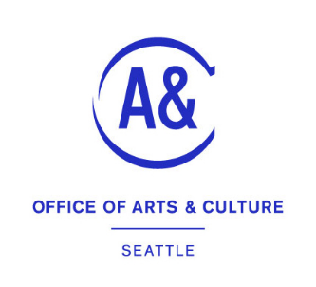
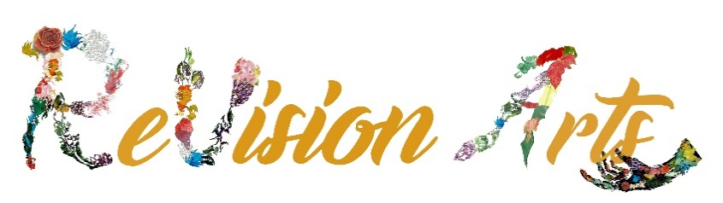

Arts and Culture Neighborhood Recovery Program
ReVision Arts for the Rainier Valley

Application & Budget

How to Submit Your Application:

Please type in minimum 18-point font. Submit one signed copy.
MAIL TO: ReVision Arts, P.O. Box 28955, Seattle, WA 98118
EMAIL TO: boswald.revisionarts@gmail.com

Applicant Name: (organization or small business):

Are you applying with a fiscal sponsor? If yes, name of fiscal sponsor:

Project Contact Person: Position/Title:

Mailing Address:

City State: Zip:

Phone (work/daytime): ( )

Email:

Person Who Will Sign Contract and Invoice

Check if same as Project Contact Person. If not, fill out name and title below:
Name: Title:

Tax ID #: Website:

YOUR PROPOSED PROJECT:
Project Title:

Total Amount Requested:

Specific Location or Address of Activation/Event: Must be in Rainier Valley and at a accessible location (if more than one event, list below)

Specific Start Date and End Date for Project Activation/Event: Must be between April 10-August 31, 2023 (If more than one event, list below)

If event(s) are not free, include proposed ticket prices, if applicable, for above events:

NARRATIVE QUESTIONS:

Project Description: Describe the activities of your accessible festival, event, or project for which you are seeking funds. Include information about how arts and culture will be featured in your project or event and geared toward to Rainier Valley audience/participants. (25 points)

Community Building, Outreach, and Accessibility through Arts and Culture: Does the project have a clear plan/vision for how these funds can have a tangible impact on Rainier Valley, particularly those most impacted by COVID-19? How does it include Disabled, BIPOC, low-income, and underserved elements of the community? How will you, either directly within the project or for the targeted audience (i.e., inclusive), engage diverse populations, and increase accessibility? (40 points)

Americans with Disabilities Act: (resource: Northwest ADA Center | ADANW (nwadacenter.org) )
How does this project specifically include people with disabling conditions? How does the project demonstrate to the public a clear message about access? (10 points)

Background and Capacity: Do you have a history of arts programming and presenting activities? Do you have a viable plan to ensure the success of your event? Are there key partnerships (with organizations, groups, or individuals) that will assist in the successful completion of this project or event? (25 points)

Project Budget EXPENSES
Item | Cash | Non-Cash  (any donated portion of your budget that you’re not having to use cash for)
Project Staff (Non-Cash includes volunteers contributing their time)
Materials/Supplies/Rentals
Publicity/Marketing
Other (such as business license fees, insurance, if needed)
Sub-Totals Cash & Non-Cash
TOTAL EXPENSES (Includes Cash = Non-Cash. TOTAL EXPENSES must equal TOTAL INCOME. | $

Project Budget INCOME (Non-cash income should equal the amounts shows above under Non-cash expenses)
Income source (list only applicable sources) | Cash | Non-Cash | Confirmed (Y/N)
Neighborhood Recovery Funding Request
Volunteer or Paid Staff or in-kind contributions from within the organization/ business (Non-Cash)

External Donations from Businesses, Foundations, or other Government sources (list)
External Donations from Individuals

Sub-totals, Cash & In-kind
TOTAL INCOME, (must equal total expenses) | $

Supporting Material. Optional: You may attach one but no more than two pieces of supporting material such as a brochure, past events, newsletter.

By signing, I declare that the information in this application is true and accurate to the best of my knowledge:
SIGNATURE OF APPLICANT OR AUTHORIZED REPRESENTATIVE (if emailing your application, scan this signed page)

_______________________________ ____________
SIGNATURE DATE

SIGNATURE OF FISCAL SPONSOR AND TITLE

_______________________________ ____________
SIGNATURE DATE

